**STEP 2: CREATION OF THE UNITY APPLICATION.**

1)Vuforia Configuration:

Go to the vuforia’s official website(from the link in the References) and sign in  
or sign up if you do not have the previous account in Vuforia.  
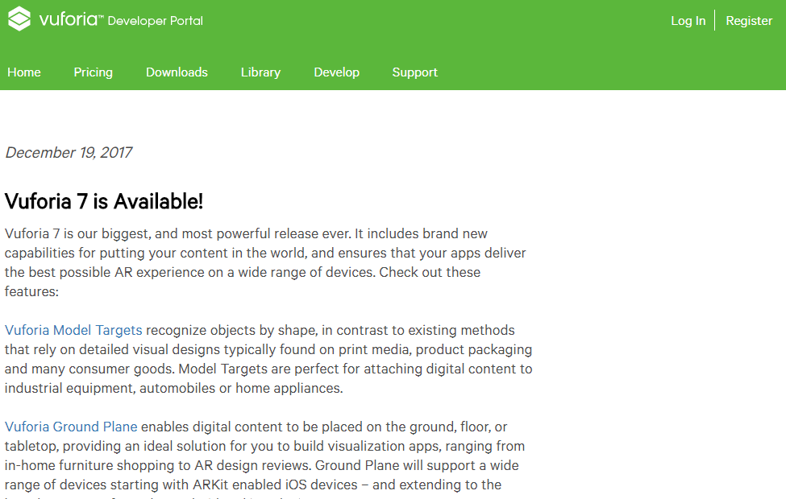  
The welcome screen of the Vuforia is  
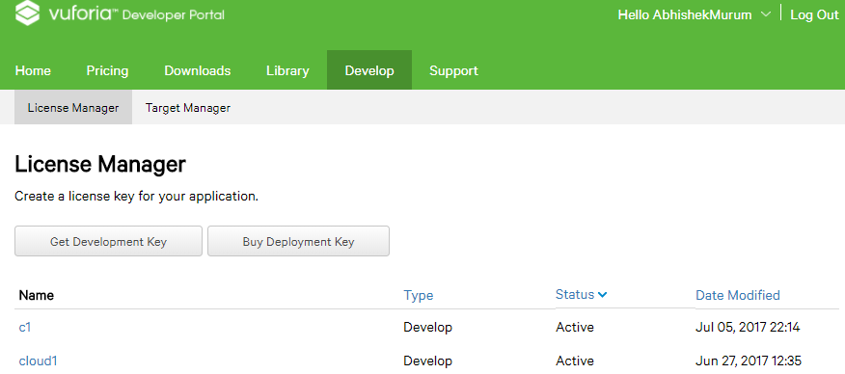  
  
Press on the ‘Get Development Key’ and fill the corresponding details.  
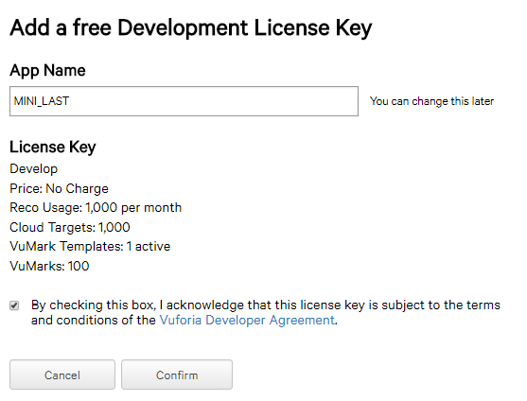  
and click on confirm  
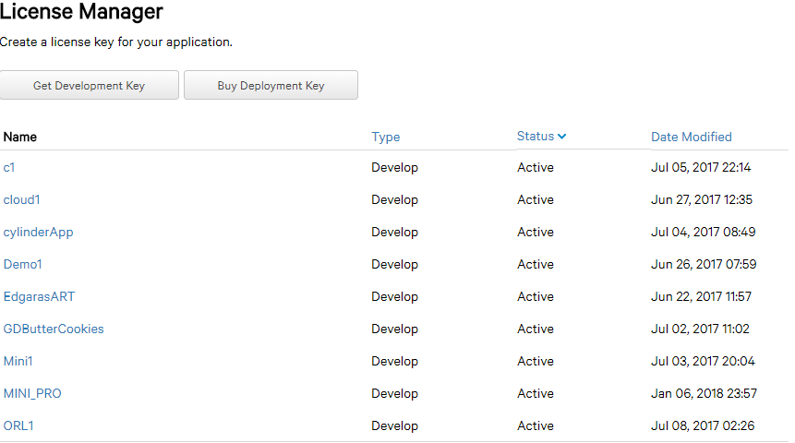  
this shows us the lists of application keys made by us.Hence click on our key ‘MINI_PRO’ which shows the License  
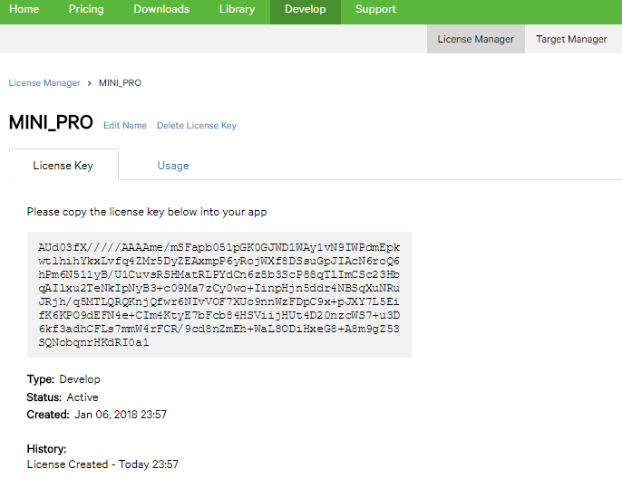  
Then move to the ‘Target Manager’ tab.  
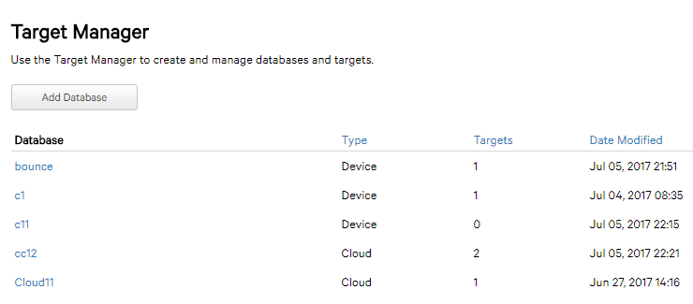  
To create new target click on ‘Add Database’. Then fill the appropriates and click on ‘create’.

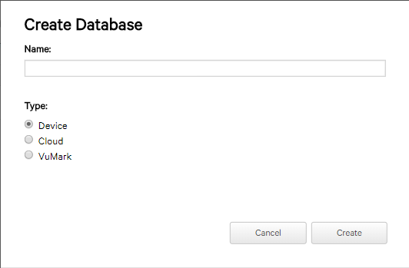 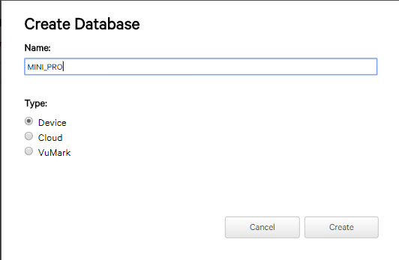  
Click on ‘MINI_PRO” to have ImageTargets as option  
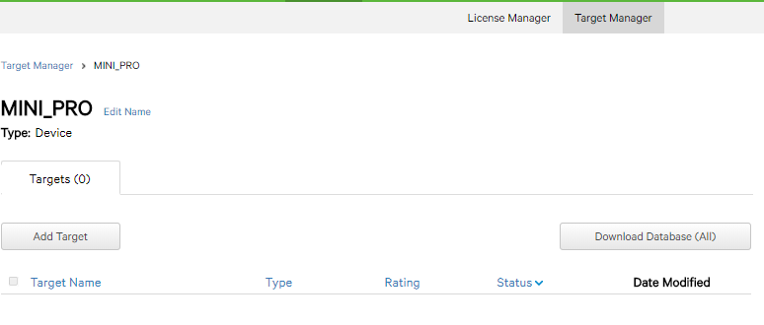  
where ‘Add Target’ lets to add our own image as Target.Click on ‘Add Target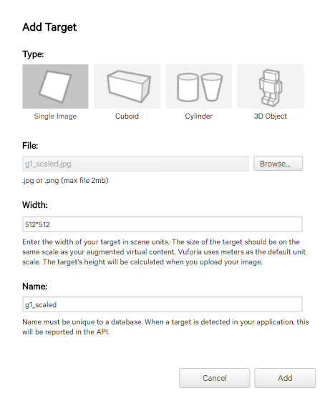  
After filling the appropriates click on ‘Add’.This will upload the target into cloud.  
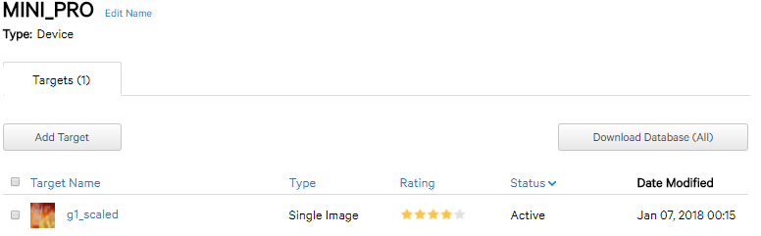  
Hence we see our target image.  
Now Click on ‘Download Database’ to obtain the Unity package of respective Image Target.

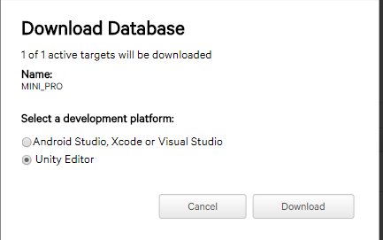  
Click on ‘Download’.  
  
click on ‘Save’  
  
Click on the saved package to open in the unity editor.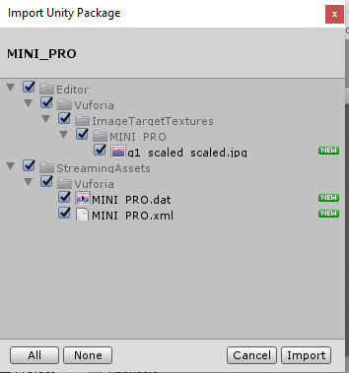  
Import Everything and click on ‘Import’

3)Setting a Response for the Image Target in the Unity  
go to.  
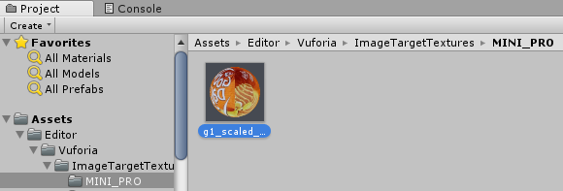  
on the right hand we can see  
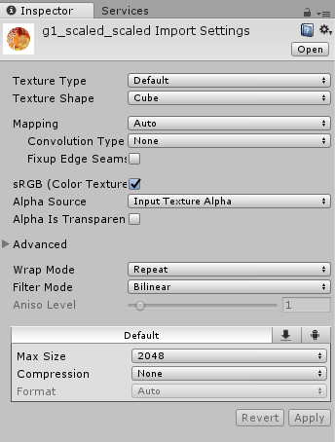  
Thus change the option ‘Cube’ as “2D” to render it as Image.  
Now go to Projects Tab and select the Vuforia folder  
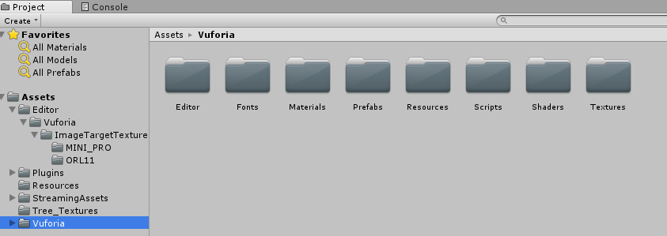  
Then Select the Prefabs  
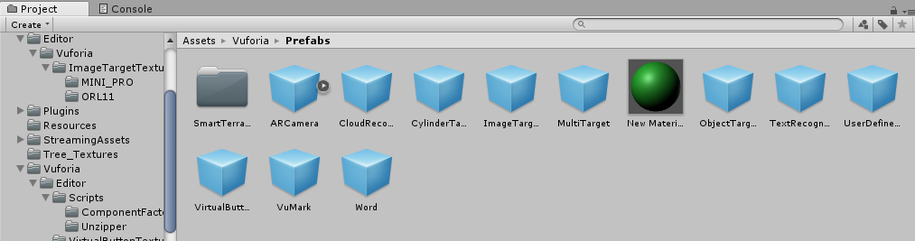  
Drag the ‘ImageTarget’ and drop in the Hierarchy plane.  
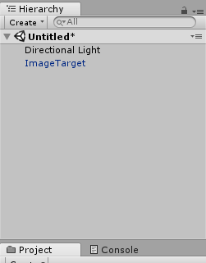  
Click on it to get into ‘Inspector’ tab.  
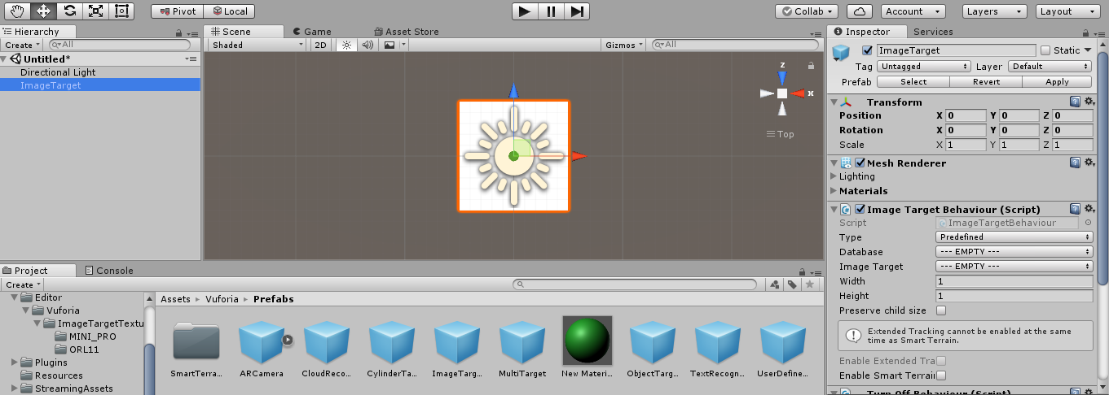  
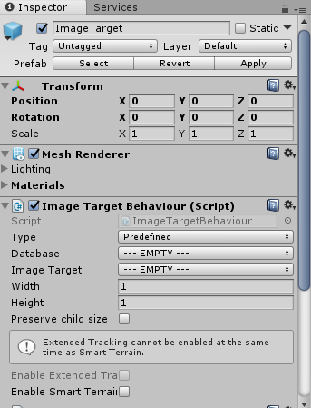  
Set the MINI_PRO option in the Database and choose the Image Target.  
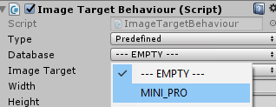  
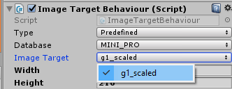  
This displays our Image Target.  
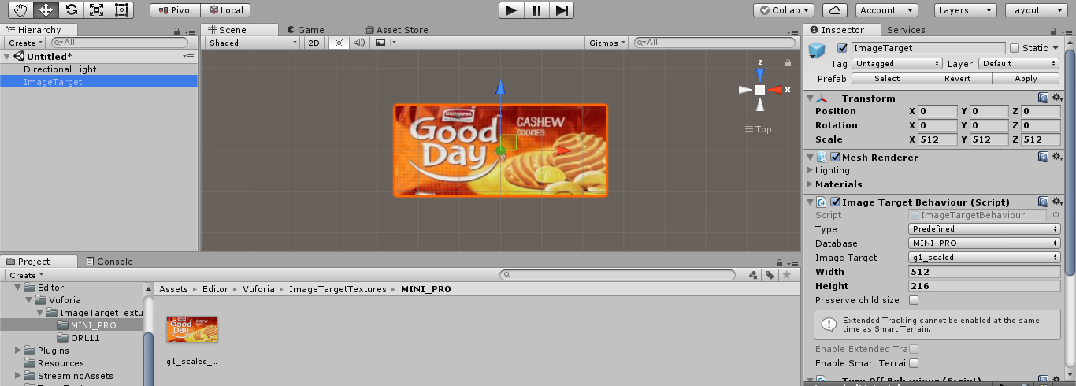  
Thus rename the Image Target as ‘actionButton’  
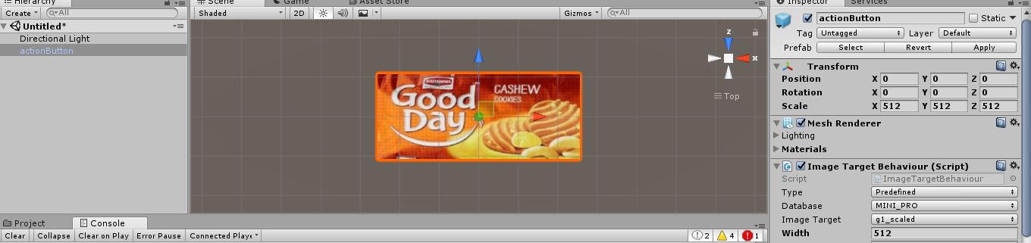  
Lets add a Virtual Button.This is done by dragging the ‘Virtual Button’ in the ‘Prefabs’ folder and dropping it on the ‘actionButton’. Renaming the button to ‘Action’.  
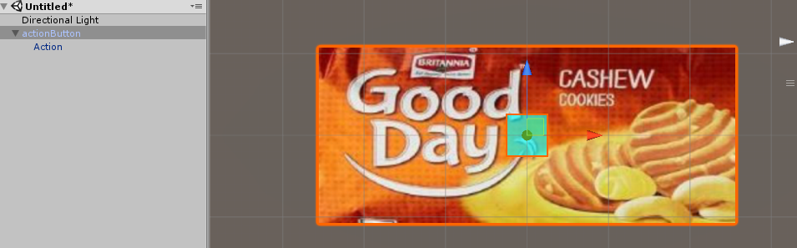  
the aqua colored square in the above image indicates the Virtual Button. Double click on the ‘Action’ and go to respective ‘Inspector’ Tab.  
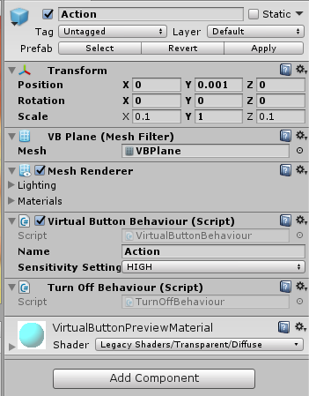   
Then click on ‘Add Component’  
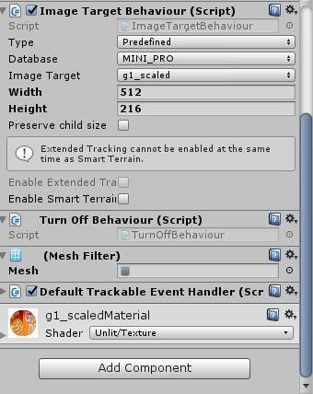  
And choose ‘New Script’  
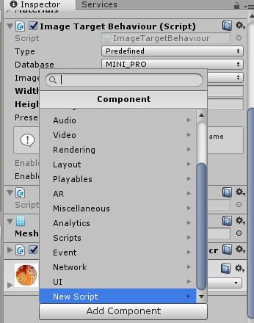  
Rename the ‘New Script’ to ‘Action’  
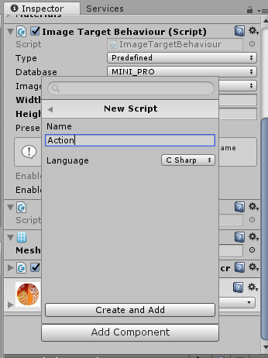  
click on ‘Create and Add’

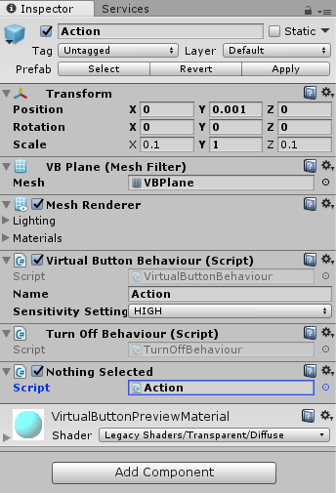  
Click on ‘Action’ to edit the script in the visual studios.  
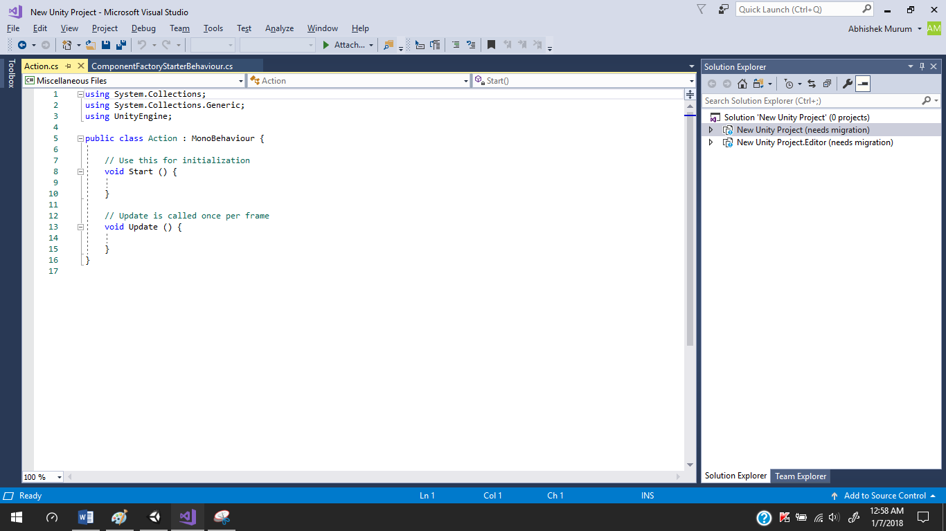  
Let us define require coding and close the file which will automatically compile the code and reports us the error. The code should be present here is given the ‘CODE’ Section of the Document. Hence Close the studios and edit the virtual button as  
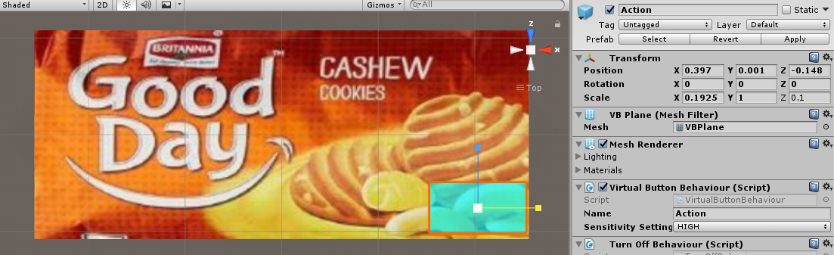  
Then move to the ‘Hierarchy’ Tab.  
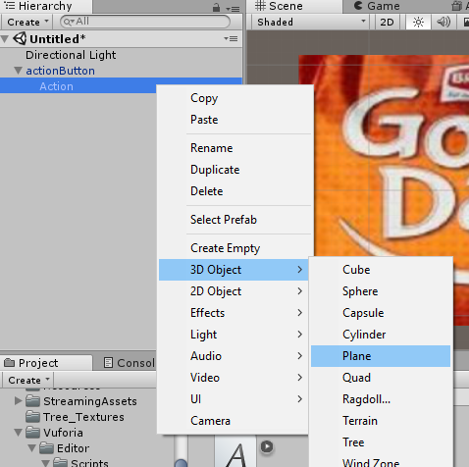  
This add a Plane in to our project.  
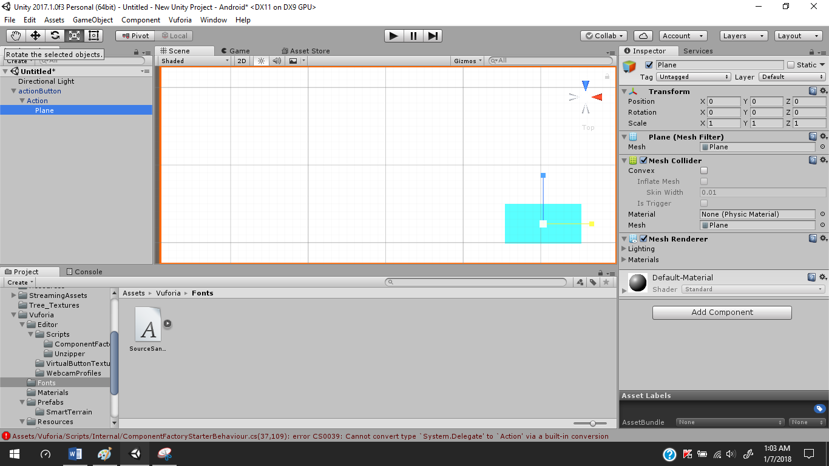  
edit the plane such that is present over the Virtual Button or Action.  
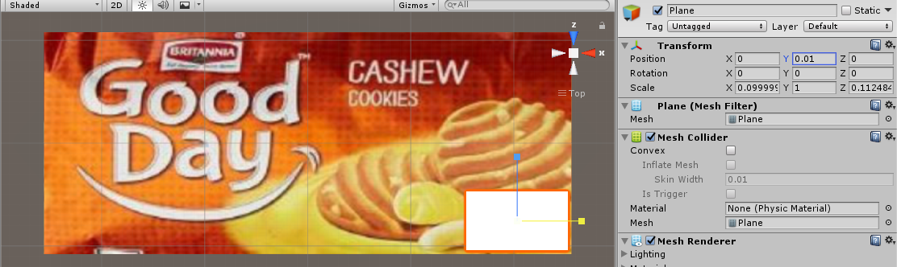  
Now Place Some Text on the Plane  
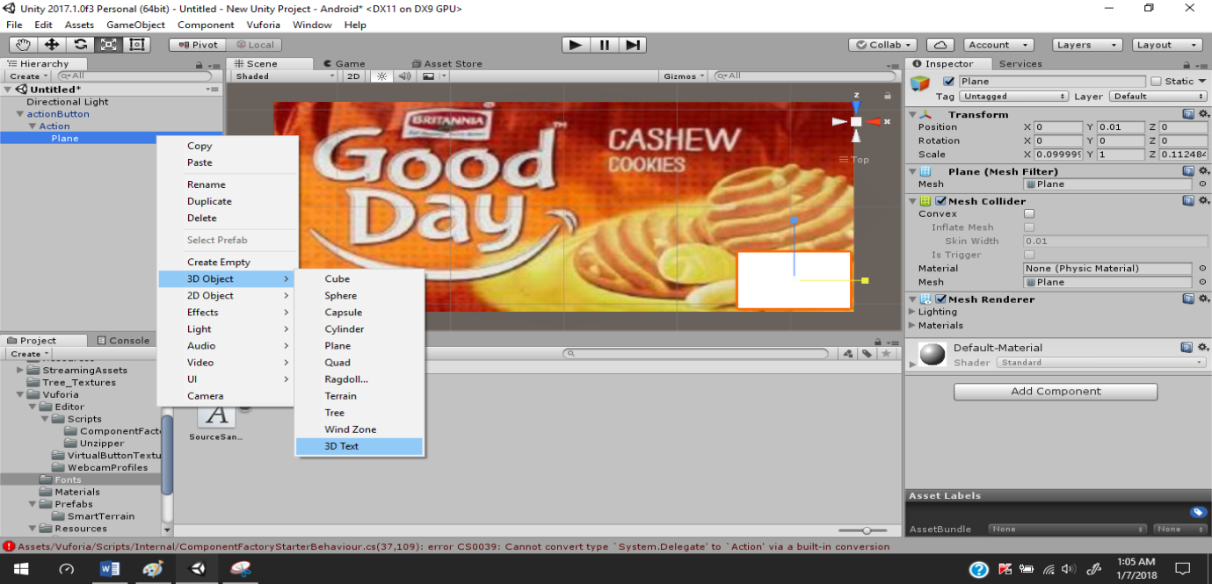  
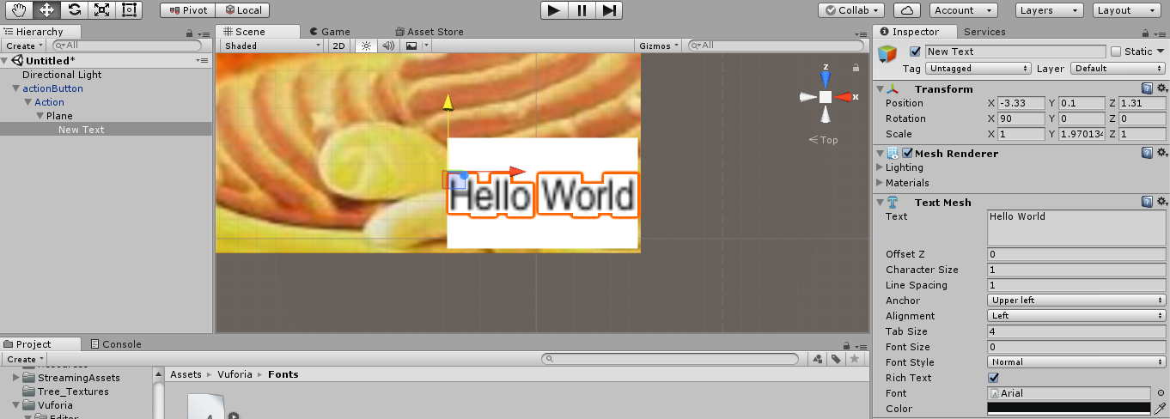  
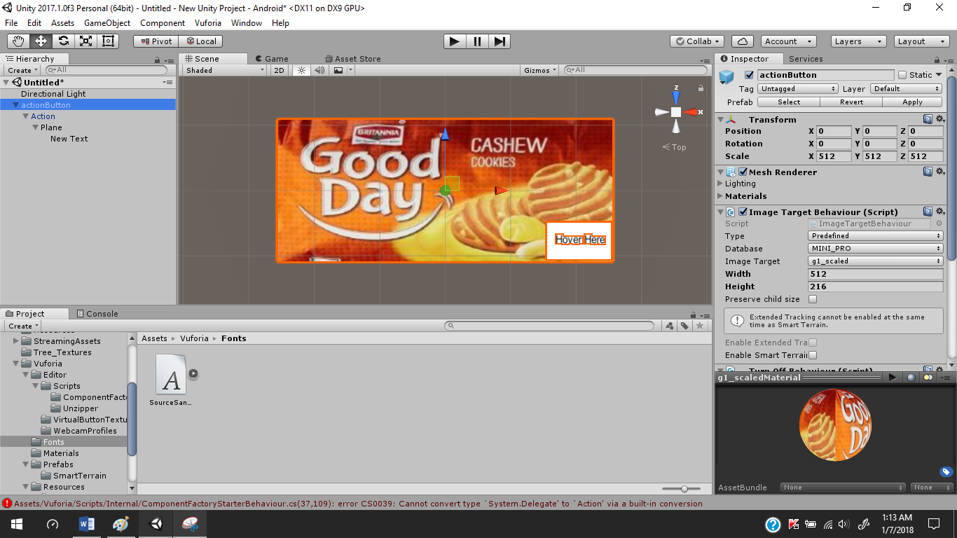  
Click on ‘File’  
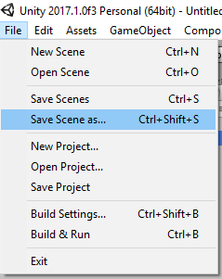  
Choose ‘Save Scene As’  
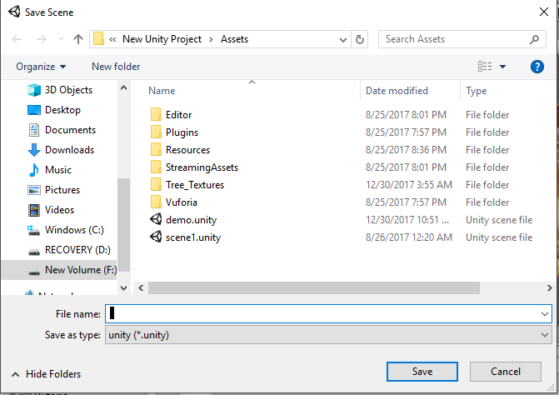

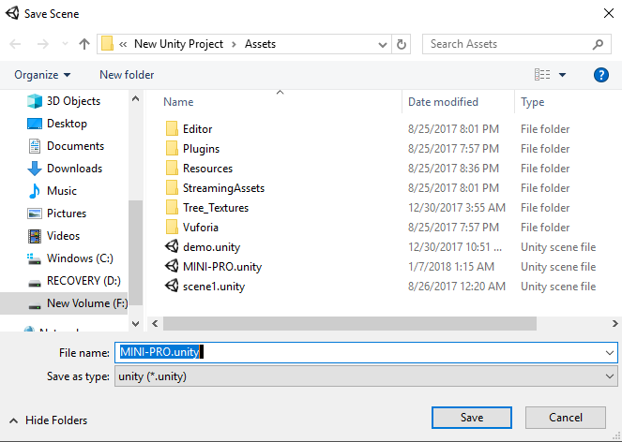  
  
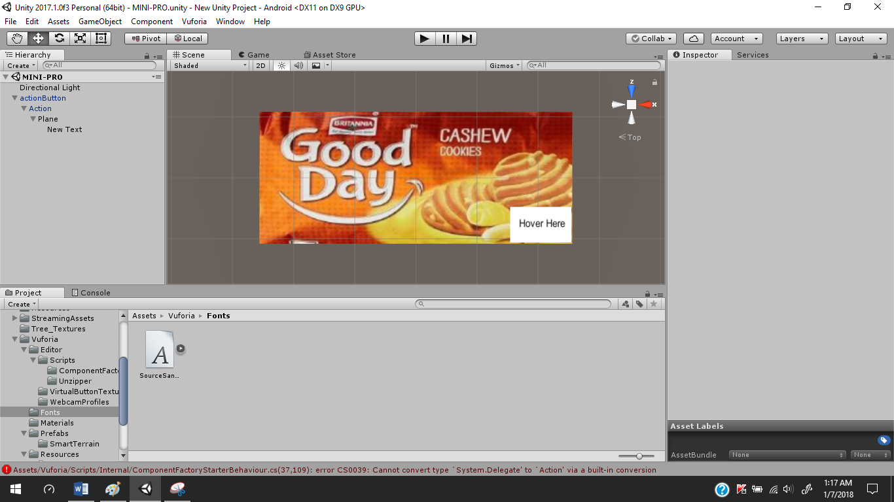

**6.3)Transforming the Unity app to android.**Connect the android phone to pc and choose the ‘Transfer Files’ option on your phone  
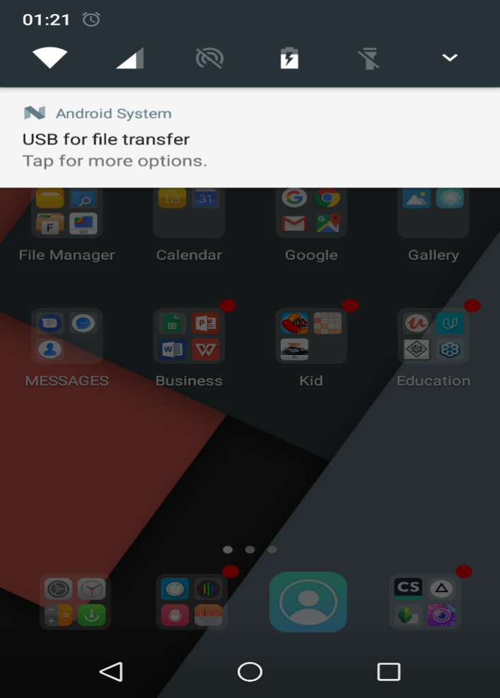  
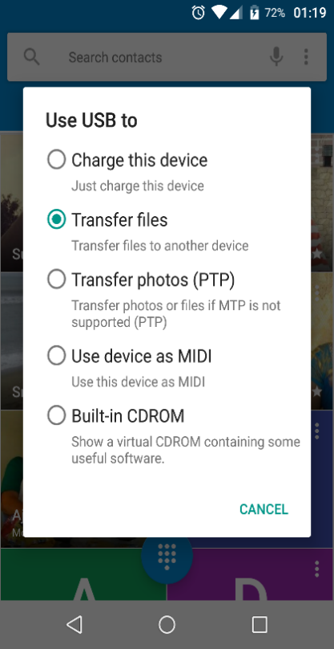  
Then in the Unity editor go to  
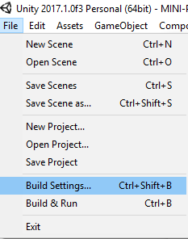  
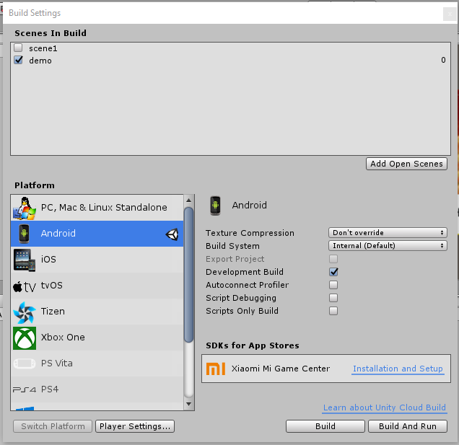  
Click on the ‘Player Setting’ and move to ‘Inspector’ tab.  
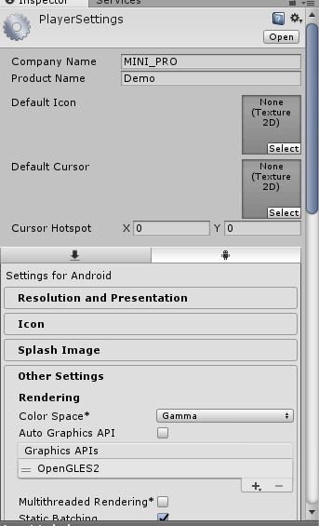  
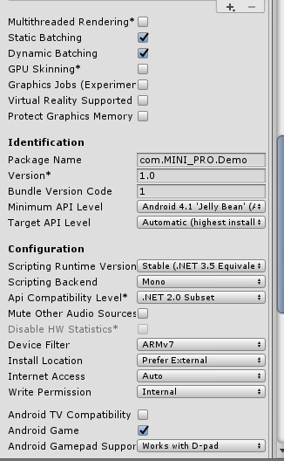  
Save and build again ,Let the app named as ‘Apps’. Then  
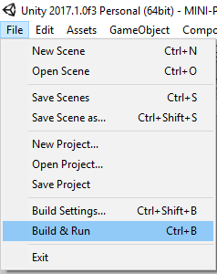  
This will install the app in to our phone

**6.4 Creating a website.**

There are many ways to create a website which is mainly used to show the information as the app scan correct Image Target. Thus the Final output is the web page that is displayed but it first needs to be deployed properly. The code of the web page can be given in the CODE Section of Document.

**6.5 Deployment of Website:**

Go to XAMPP Installation folder then click on ‘xampp-control.exe’ to show the control panel of xampp.  
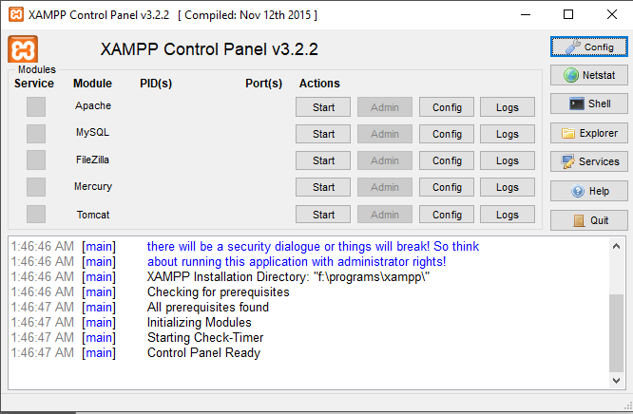  
Then click on ‘Tomcat’ which starts the server we can check the connection port by clicking on ‘config’ and then select’servers.xml’ search for ‘connection-port’. For my system it was 8083. Now open a browser and log on to the server.  
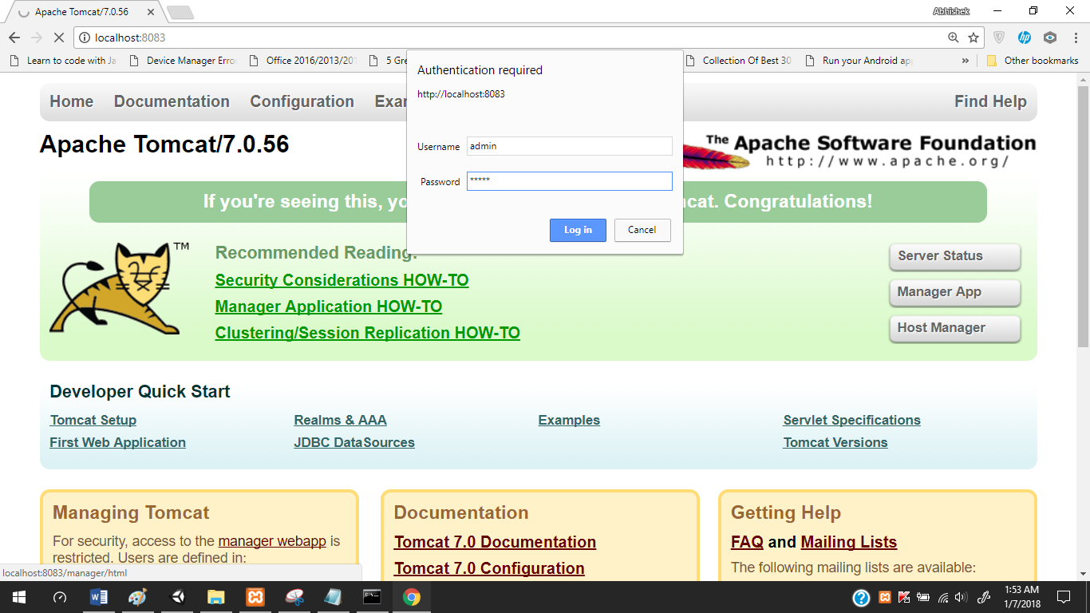  
when we login we see

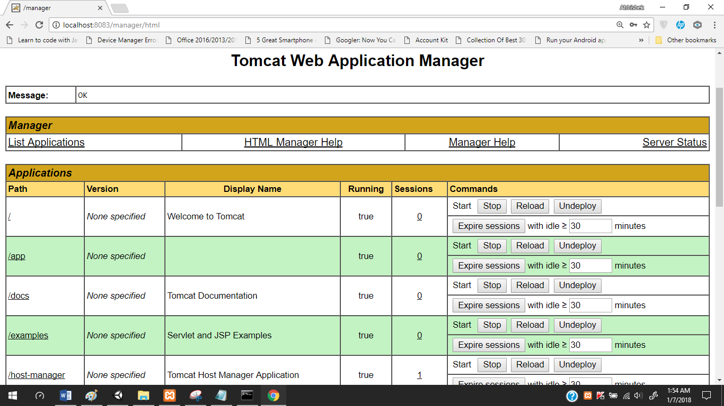  
list of projects here.  
Now let us add the files of our webpages to   
xmapp_installation_folder > tomcat > web-apps > paste the whole website here.